Archived News

2023

February
GRANDMOTHERS WELCOME RIGHT TO STAY FOR 19,000 REFUGEES Read here.

2022

November
MAKING THE COST/BENEFIT CASE FOR SETTLEMENT SOLUTION FOR ALL UMAs
Write to your local MP and Senators about this issue. Find your local MP and Senator here.
>> Read here.

November
GRANDMOTHERS FOR REFUGEES GO TO THE CANBERRA CONVERGENCE
Casey Grandmothers for Refugees proudly joined a coalition of refugee communities and advocacy groups to endorse the Canberra Convergence. >> Read here.

March
NEW ZEALAND AND AUSTRALIA READ DEAL OVER REFUGEE SETTLEMENT OFFER
After nine long years for refugees, the Coalition Government has accepted the NZ offer to take 150 refugees per year for the next three years. Those eligible will be from Nauru. It still leaves 450 others without any chance of resettlement. This how the New Zealand media reported the Australian change of position on refugee resettlements across the ditch.
>> Read here.

April - October
TRAGEDY UNFOLDING IN AFHGANISTAN
Contact your local MP to support the actions outlined in this letter from Refugee Legal Executive Director, David Manne.

2021

September – October
SENATE INQUIRY INTO AUSTRALIA’S ENGAGEMENT IN AFGHANISTAN – THE GOVERNMENT FAILED TO PROTECT THOSE WHO NEEDED IT MOST
The Asylum Seeker Resource Centre (ASRC) welcomes the Senate Inquiry into Australia’s engagement in Afghanistan and calls on the Morrison Government to commit to an additional humanitarian intake of at least 20,000 people from Afghanistan as well as provide permanent protection to refugees from Afghanistan and their families.
Read this media release from the ASRC here.
AUSTRALIA ENDS OFFSHORRE DETENTION DEAL WITH PNG – REFUGEES ABANDONED
Australia is to stop sending asylum seekers to Papua New Guinea (PNG), marking an end to its controversial detention regime in the nation.
PNG is one of two Pacific countries paid by Canberra to detain asylum seekers and refugees who attempt to reach Australia by boat. Australia said its arrangement with PNG would conclude by the end of the year.
Read this report from the BBC
Australia is officially ending its controversial (read: cruel) offshore detention of refugees in Papa New Guinea (PNG). But, before you get excited, this isn’t really good news — the refugees that are currently there will be left without resettlement to Australia.
Read this report from pedestrian.tv
Read here from The Department of Home Affairs
Make a submission here
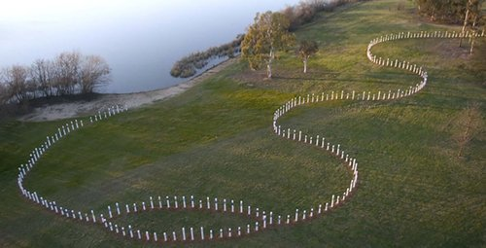
WHAT HAPPENED TO THE ASYLUM SEEKERS ABOARD SIEV X?
Twenty years after it sank, there is still a terrible mystery about what happened to the asylum seekers aboard SIEV X and why they were not rescued by Australia.
Read this article from The Saturday Paper, 9 October 2021
NO PLACE LIKE HOME – THE BOLOELA FAMILY The story behind the headlines of a family in limbo.
Read the article from ABC News Watch ‘Australian Story’ on ABC View

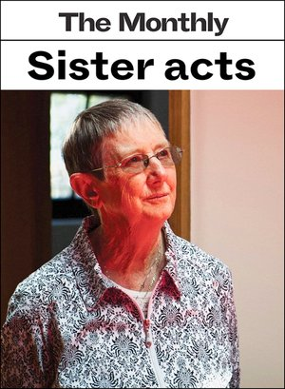

August

THE LIFE AND TIMES OF ACTIVIST SISTER BRIGID ARTHUR
Twenty years ago, I had reason to visit someone in the Maribyrnong detention centre, in Melbourne’s inner west. The people who sent me told me to meet a nun outside who would introduce me to the detainee. I spotted her in the car park: a small woman, casually dressed and watchful, propped on two crutches. In answer to my query, she muttered something about her hip. After we passed through security – a processing desk, a metal detector and some suspicious looks – we were dumped in an interview room and the door slammed shut behind us. Immediately, the nun began producing an astonishing array of stationery from within her clothing: pens, highlighters, Post-it Notes, paper. “They won’t give them stationery in here,” she said. “And no one pats down a nun.”
Read the full story here.

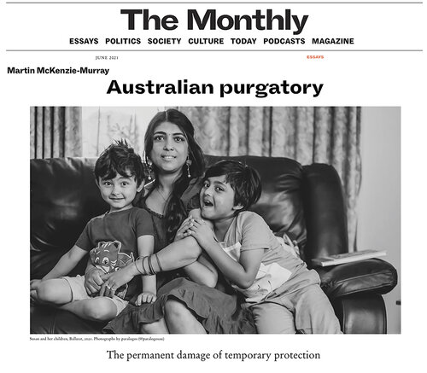
NOTES FROM MEMBERS’ BRIEFING by David Manne (Executive Director) and Ben Goulding (Senior Lawyer) of Refugee Legal to GFR June 9, 2021.
Notes courtesy of Member, Gillian Essex
Read here.
AUSTRALIAN PURGATORY
“This terrible, permanent temporary status in which people have been admitted into Australia – they have no home to return to. They clearly pose no threat to national security, or national security agencies wouldn’t have allowed them in the country.
But they can’t get on with rebuilding their lives.”
Read this article by Martin McKenzie-Murray in The Monthly here.

January – April

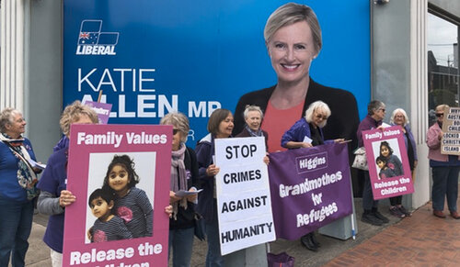
HIGGINS GRANDMOTHERS GO VIRAL
The photo and message I posted on Thursday 22 April has gone quite viral. It is now heading up to 68,000 views!!
My phone is still getting alerts every few minutes. It has brought us 60 more followers to date – thus increasing our ability to publicise our activities on social media more widely. 38 people have written responses and it has been retweeted 433 times and liked by 1,200. And more will come. Because the tweet is tagged, Katie Allen’s office will see that there is much disquiet – even anger – about her refusal to speak up on behalf of the Tamil children.
I wonder if she will now think it might be wise to meet with you Helen, Rayna, Sue and more of the Higgins Grandmothers for Refugees!
POSTSCRIPT: On 23 April Katie Allen’s office DID contact us to set up a meeting. YES!
From Linda Sparrow, G4R ‘tweeter extraordinaire’
‘Many prisons, many borders, many islands: Spicy’s story’
by Behrouz Boochani and Omid Tofighian from The Overland
Read Spicy’s story here.

BILOELA TAMIL FAMILY
1. Biloela Tamil family to remain on Christmas Island after federal court upholds ruling on daughter's visa
Court denounces government’s ‘Kafkaesque’ handling of visa application for youngest Australian-born daughter,
who is being detained indefinitely with her family.
Read the full story in The Guardian.
2. Biloela family wait for compassion
The Tamil family who settled in Biloela, Queensland, with their two Australian-born daughters have now spent more than 1000 days in immigration detention.
Read the article from The Saturday Paper.
3. Biloela Family Letter-Blitz Day Monday 5 April
Write your letter in support of the family using the Letter-Blitz Kit here.
Scores of medevac refugees have been released from detention. Their freedom, though, remains tenuous.
Over 100 refugees have been abruptly and quietly released from immigration detention in Melbourne, Brisbane and Darwin hotels since early 2021. These releases are welcome and long overdue, following a sustained public campaign for their freedom.
Read this article from The Conversation here.
‘I’m voting against the mobile phone bill’ Jacqui Lambi
Thanks to all of you who wrote to or telephoned Jacqui Lambie’s office about the government’s attempt to empower guards to remove mobiles from asylum seekers and refugees in detention. Some of you may also have responded to her survey. She has announced that she will vote against the bill if it is introduced to the Senate. This is a wonderful example of what we can achieve when we work together. Thank you!!

2020

October - December
Dutton Defeated in High Court by Refugees 2 December 2020
Read here.
Farhad Rahmati disappeared from Brisbane Immigration Transit Accommodation
Media Statement from the Refugee Action Coalition, 29 October
Read here.

September

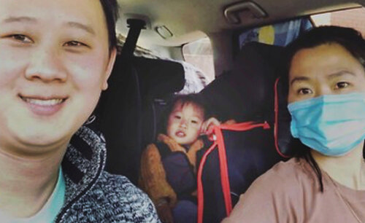
Baby Isabelle and her mum, Huyen, are freed from detention
We rejoice with everyone – not least our own Grandmothers and FROGs – who have advocated, written letters, pleaded for compassion and agitated for this little girl who has been held in detention since her birth in March 2018.Many of us joined a Winter 2019 rally outside the MITA gates. We then read stories to symbolically empty chairs – highlighting the very real separation of detained children from their families and nurturing communities.
With the release of Isabella, it now means Kopika and Tharunicaa are the only children remaining in detention in Australia. In learning the news Priya states:
“I’m so happy to hear that Isabella, Huyen and Paul can live together as a family. They have had a very difficult time in detention, every day is hard in detention. But today is a good day for them. I am waiting in hope that the government will make a similar decision for my family, so we can rejoin our community in Biloela.”

14 August
First immigration detention transfers from Yongah Hill to Christmas Island
Read the Media Release from the Refugee Action Coalition 14 August 2020

24 July

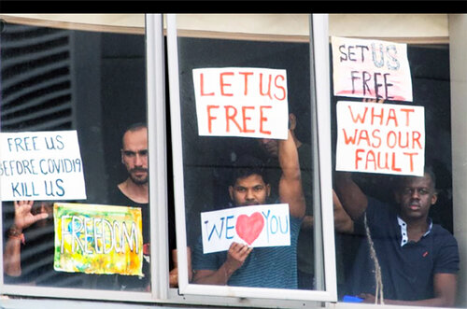

﻿Darebin Council to investigate possible permit breach at Mantra ‘Prison’
Grandmothers for Refugees and Councillor Gaetano Greco released a media statement today (24 July 2020) about Darebin Council’s investigation regarding the use of the Bell City Mantra Hotel to detain refugees as a possible breach of planning permission. Read the Media Statement here.

24 July

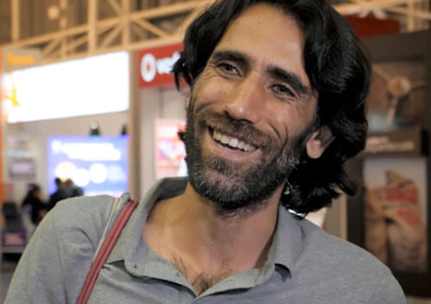
Behrouz Boochani granted refugee status in New Zealand
Behrouz Boochani, the Kurdish Iranian exile and journalist who became the voice of those incarcerated on Manus Island, has had his refugee status formally recognised by New Zealand, and granted a visa to live there.
Read this exclusive report from The Guardian.
Behrouz Boochani just wants to be free
Read this article or listen to the podcast
from The New York Times.

18 July

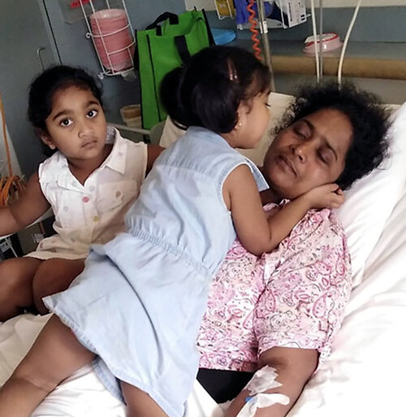
Priya in Christmas Island hospital before she was taken to Perth.
Biloela family separated as mother is taken to Perth
After multiple hospital admissions on Christmas Island following two weeks of crippling abdominal pain, Priya Murugappan was evacuated by air for medical treatment in Perth on Saturday 18 July.
Read the article from SBS.
Biloela Tamil family separated as mother flown to Perth for medical treatment.
Read the article from The Guardian.
Mum from Biloela Tamil family seeking asylum flown to Perth from Christmas Island for medical treatment.
Read the article from ABC News.﻿

11 June

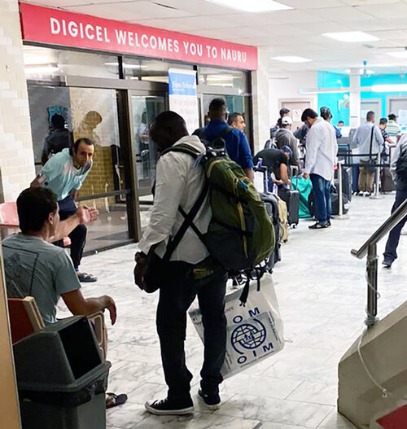
Refugees leaving airport
Nauru and Manus refugees leave for US resettlement
Four refugees from Manus Island and 24 from Nauru will leave today (Thursday 11 June) to fly to the USA via South Korea. The 24 Nauru refugees include Pakistanis, Rohingyans, Sudanese, Somalis and one Tamil. They are destined for different cities and states in America, including Chicago, Philadelphia, Texas and California.
They are finally being resettled almost seven years after seeking asylum in Australia. It has taken three and half years since the US deal was first announced, in November 2016, for this group of refugees to finally be resettled. And there are people still waiting.
“It is worse than tragic that the refugees are going from countries where there is no risk, or almost no risk of the coronavirus to a country where the risk of infection is still high and the chance of getting a job is essentially non-existent with 40 million unemployed in the US,” said Ian Rintoul, spokesperson for the Refugee Action Coalition.
“All of those on Nauru and PNG should be brought to Australia and given the safety and protection they asked for in 2013,” he said.
Around 200 refugees and asylum seekers are still being held on Nauru, and another 180 still in limbo in PNG. Around 200 refugees from Manus and Nauru are being held in detention centres and hotel prisons in Australia.
For more information contact Ian Rintoul 0417 275 713
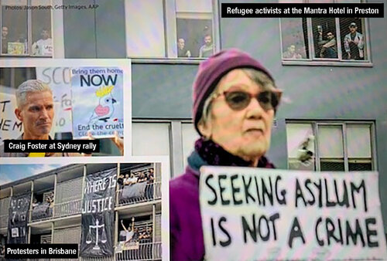

14 June
Rallies go ahead despite threats
Read this article from The Age here.

24 June
Refugee supporters lock themselves in cage at Mantra detention hotel
At 7.30am refugee supporters locked themselves in a cage outside the Chill restaurant at the Mantra Hotel complex on Bell Street in Preston. Read the report from Whistleblowers, Activists and Citizens Alliance.

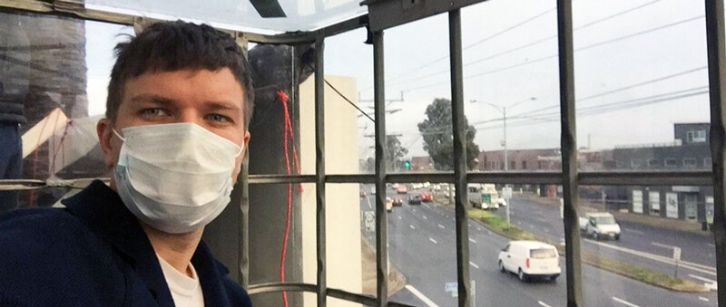

The Victorian Government has allocated $2.2 million to provide basic needs assistance to thousands of asylum seekers in the state.

6 May
The Victorian Government has allocated $2.2 million to provide basic needs assistance to thousands of asylum seekers in the state.
The funds are part of $11.3 million announced as assistance for Multicultural communities, affected by COVID-19 conditions. Multicultural Affairs Minister Ros Spence said these communities are facing their own unique challenges due to social isolation, language barriers or difficulties accessing services such as income support, Medicare or Centrelink.

1 May
The closed Maribyrnong Immigration Detention Centre is to reopen to house men due for release from Victorian Prisons.
The re-purposing of the Maribyrnong facility will allow the State Government to ensure prisoners are not released into homelessness. In the meantime, refugees and people seeking asylum are still being held in the prison-like Melbourne Immigration Transit Accommodation (MITA) at Camp Rd, Broadmeadows. Security at that facility was upgraded to accommodate offenders designated for deportation and previously held at Maribyrnong.
In the pandemic environment, the re-opening of the Maribyrnong Centre appears to be lifting the risk of cluster outbreaks of Covid-19 in Victoria.
Grandmothers for Refugees has written to the Premier asking him to speak up at National Cabinet for the release of refugees from detention so they can more safely isolate and follow good hygiene practices in welcoming community settings.

25 April
Kurdish musician, Fahad Bandesh, held in detention at the Mantra Hotel, Preston (Victoria) for nine months, asked a video question on ABC TV’s Q&A program last Monday night about the risk to detainees of a cluster outbreak of Coronavirus (20/4). On Thursday, reportedly around 9.30pm, Fahad was removed from the Mantra and taken to MITA at Broadmeadows.
Details are in this report and interview by Hamish McDonald on ABC RN.
CALL TO ACTION
Grandmothers are asked to write urgently to their local MP to raise their concerns about this action and the failure to address the COVID-19 risk to detainees. Please request your MP and Senator to seek a response from the Minister for Home Affairs, Peter Dutton, as to the full circumstances and reasons for (a) the removal of Fahad Bandesh to MITA and (b) the failure by federal Government to address the risk of a cluster outbreak of COVID-19 at both Mantra and MITA detention facilities. The outbreak of the disease in migrant worker centres in Singapore, as well as in aged care centres world-wide, is evidence of the pandemic risk to people living in close quarters.

21 April
Is protesting during the pandemic an ‘essential’ right that should be protected?
Freedom of political communication is implied in the constitution, but protesters have still been fined for breaching social distancing rules by leaving their homes.
Read more from this article by Maria O’Sullivan, Monash University, in The Conversation.

17 April
Latest on Biloela family
The Federal Court ruling was delivered by phone in Melbourne today to avoid crowds gathering in breach of COVID-19 restrictions. While it does not mean immediate release from Christmas Island or an obligation on the Federal Government to grant a visa, it does prevent the Tamil family from being deported immediately to Sri Lanka and requires the Immigration Minister to complete the process of considering use of his discretion to grant Tharunicaa a visa.
Read the following media reports for the full story.
• Reprieve for Biloela Family The Guardian – Read here
• Tamil girl ‘not afforded procedural fairness’ in Biloela family’s asylum bid ABC News – Read here
• Tamil family have win in Federal Court The Morning Bulletin – Read here
• Biloela Tamil family ‘not afforded procedural fairness’ in making visa claim, court rules Nine News – Read here
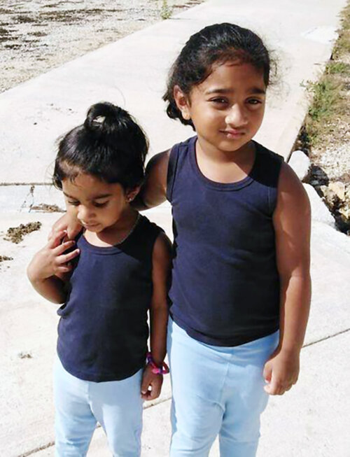
>> CALL TO ACTION
Grandmothers, please write to Minister Alan Tudge (Acting Minister for Immigration) and urge him to proceed with compassion and justice to complete his consideration of Tharunicaa’s application for asylum.
All Grandmothers in the Aston Electorate or near to the Wantirna South office, please telephone on the Electorate Office number below.
• Email here.
• Write Suite 4, Level 1, 420 Burwood Highway, Wantirna South, Victoria, 3152
(Electorate Office – Principal Office – Postal address)
• Phone + 61 3 9887 3890

Melbourne refugee protesters fined
• Melbourne refugee protesters fined $43,000 Read here – SBS News
• Man arrested, 26 fines issued, as protesters ignore COVID-19 measures Read here – 3AW radio
• Coronavirus deaths rise to 13 in Victoria, Melbourne refugee protesters fined by police Read here – ABC
Message from Refugee Action Collective (RAC) Convenor, Chris Breen
(This is an edited version of Chris’ message sent 11/4/2020)
Hi all, I have been charged with ‘incitement’ and police have seized my phone and all my computers (including my 15 year old son's computer). My court date is August 6. The charge of "incite" is not part of the new health regulations, it is a straight out anti-protest law from 1958 …
The police came to my house around 12 noon, so I did not even get to attend the protest. I spent nine hours in a police cell from around 12 noon, I had nothing to eat or drink since 9am that morning. I was offered water by police, but I didn't want to eat or drink anything in the station because police themselves completely disregarded social distancing measures, and I could not trust their hygiene.
I had to sit in close proximity with three police for half an hr in a police car waiting to get into the station. Then I sat in a car in close proximity with three different officers as they drove me to my house to raid it. In my house there were six police in total none of whom practiced social distancing (staying 1.5m away) either with myself or with each other.
Solidarity with the refugees in the Mantra, in MITA, in Kangaroo Point, in Villawood, in Yongah Hill and all across Australia, solidarity with those still held in PNG and Nauru after almost 7 years. Solidarity with every refugee supporter who was fined yesterday …
I will not stay silent, the refugee movement will not stay silent, we will not cease our protests until the camps are closed and every refugee is free.
The struggle continues.
Message from G4R Executive
Grandmothers for Refugees and several other organisations in the refugee support network decided not to endorse the Good Friday protest action at Mantra in Preston.
The Executive’s assessment was that the car cavalcade protest would be reported as a breach of Covid-19 ‘stay at home’ rules rather than give focus to the health risk threat to refugees. With the arrest and fines, that has proved to be the case.
The challenge now is to keep the focus for lobbying and action on refugees, while always protecting our own basic rights as citizens.
The Executive invited a wider group of Grandmothers including the Planning Group to an online meeting on Saturday afternoon. We agreed, as a movement, not to be distracted from our core purpose to campaign for our personal freedoms. We resolved to mount a media campaign with a members Call to Action.

Federal government must act urgently to avoid COVID-19 catastrophe in immigration
Download the Media Alert here.

Doctors call to release detainees at risk from COVID-19
Read the letter here.

New fears for asylum seekers in PNG and Nauru
Read this article from The Saturday Paper, 4 April 2020

10 April
Article from The Conversation. In this contribution from Gillian Triggs, Grandmother and former Human Rights Commissioner, Gillian writes of her inspiration from Grandmothers for Refugees, activist women, and her own grandmother.
Friday Essay: Today’s grandmothers grew up protesting. Now they have nothing to lose.
Grandmothers as social activists? What a radical idea … but one that is increasingly true of today’s generation of grandmothers.
A sweet memory of my time as president of the Australian Human Rights Commission was being asked by my executive assistant to look down from my Pitt Street office to the Grandmothers for Refugees singing in the street below to support the commission and its advocacy for refugees detained indefinitely in offshore detention camps. What a delight to see the men in their suits walk by in bemused wonderment. How mistaken to dismiss these grandmothers as having passed their use-by date.
Why should we be surprised? This generation of grandmothers came from the 60s and 70s, many – and for the first time in history – spending formative years at university with free or minimal fees, marching against Vietnam, experimenting with sexual liberation, burning our bras and “making love not war”. Political activism is mother’s milk to many of the women from those times.
Over the following years, this unique generation of women rode the crest of a wave of opportunity and optimism. The Sex Discrimination Act was passed in 1984 … problem of equality fixed. The future was ours. And, to a significant degree, so it has been.
Today, women over 60 are often well-educated and financially independent, having had a fruitful career while also doing a decent job of raising their children. Today, the 60s generation of women is emerging as a political force to be reckoned with ….
… as grandmothers, we should use our remaining years and decades to reach out to our less privileged sisters to bring them with us. Too many women have been left behind. The promises of the 60s and 70s have not been met fully for all Australian women. We grandmothers now have a responsibility to advocate, to be politically active in using our education and financial independence to ensure equality of opportunity and outcome. For all women …
Bravo to Grandmothers for Refugees, the Older Women’s Network and the scores of other women’s advocacy and networking groups. Let us work together to harness the power of today’s generation of grandmothers, who can and will speak up for social justice. Let us work together to achieve the vision of gender equality that we and our political leaders had in the 60s and 70s.
This essay is an extract from Grandmothers: Essays by 21st Century Grandmothers edited by Helen Elliott and published by Text. Read the full article here.

25 March
RCOA has released its Priorities for Protecting People Seeking Asylum and Refugees During Covid-19 Pandemic. Follow the link.

19 March
Infectious disease specialists advocate for detainees: “consider their release”.
“We represent the Australasian Society for Infectious Diseases and the Australian College of Infection Prevention and Control, the peak professional bodies for infectious diseases physicians and infection control practitioners respectively.
“We understand that around 1400 asylum seekers and other non-citizens are being held in detention in crowded conditions that would preclude adequate social distancing or self-isolation. This would potentially pose a risk to their health in the event of an outbreak of COVID-19, as outbreaks in other crowded settings, including detention facilities, have been well documented to date. This would also potentially pose a risk to staff who work at immigration detention facilities and, through the amplification of infection, the broader Australian community.
“We urge the Commonwealth government to consider the release of detainees into suitable housing in the community if they do not pose a significant security or health risk.
“As a minimum standard, we would recommend that detainees should be held in single rooms with their own bathroom facilities. While this would not fully address the risk associated with COVID-19, and it certainly would not be as effective as reducing the overall numbers in immigration detention facilities, it would go some way to reducing the risk and could be considered the absolute minimum necessary step.
“Yours sincerely
A/Professor Joshua Davis, President, Australasian Society for Infectious Diseases Limited.
A/Professor Philip Russo, President, Australasian College for Infection Prevention and Control.
See the full letter here.

March
ASRC-sponsored Petition to protect people seeking asylum and refugees in COVID-19 crisis.
People seeking asylum and refugees are experiencing insecure work, extreme poverty, mental and physical health decline and homelessness. Thousands are excluded from the safety net of Medicare and Centrelink. They face extreme hardship, risk of infection, and loss of life in the economic and health crisis that COVID-19 is creating.
Anne Ruston MP, the Minister for Families and Social Services, has been delegated special powers to grant social security benefits for the COVID19 crisis. Greg Hunt MP, the Minister for Health, has powers over Medicare.
>> CALL TO ACTION
Sign the petition calling on Prime Minister Scott Morrison, Minister Ruston, and Minister Hunt to introduce emergency measures to protect people seeking asylum and refugees. >> Go to the petition.﻿

